**DBMS Lab**

**Assignment No. 2(MySQL Basic Queries)**

**Title:** Design at least 10 SQL queries for suitable database application using SQL DML statements: Insert, Select, Update, Delete with operators, functions, and set operator.

* **Create Employee table, Project table and add rows shown below**

|  |  |  |  |  |
| --- | --- | --- | --- | --- |
| **Eid** | **EName** | **Address** | **Salary** | **Commision** |
| **1** | Amit | Pune | 35000 | 5000 |
| **2** | Sneha | Pune | 25000 |  |
| **3** | Savita | Nasik | 28000 | 2000 |
| **4** | Pooja | Mumbai | 19000 |  |
| **5** | Sagar | Mumbai | 25000 | 3000 |
| **6** | Rohit | Jaipur | 40000 |  |
| **7** | Poonam | Patana | 45000 | 2000 |
| **8** | Arjun | Delhi | 20000 | 900 |
| **9** | Rahul | Nagpur | 60000 | 5000 |
| **10** | Dulquer | Kochi | 30000 | 1000 |

|  |  |
| --- | --- |
| **PrNo** | **Addr** |
| 10 | Mumbai |
| 20 | Pune |
| 30 | Jalgoan |
| 40 | Nagpur |
| 50 | Delhi |
| 60 | Kochi |
| 70 | Pune |
| 80 | Nasik |

**mysql> show databases;**

+----------------------------+

| Database |

+----------------------------+

| dbms |

| information_schema |

| mysql |

| performance_schema |

| sys |

+----------------------------+

5 rows in set (0.00 sec)

**mysql> use dbms;**

Reading table information for completion of table and column names

Database changed

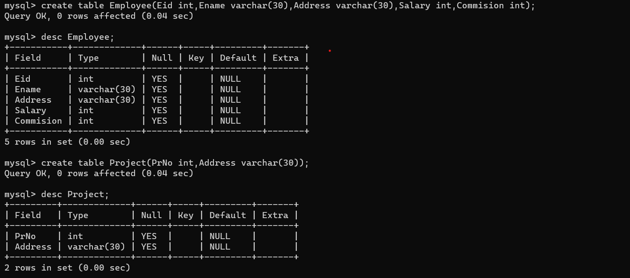

**mysql> insert into Employee values(1,'Amit','Pune',35000,5000);**

Query OK, 1 row affected (0.01 sec)

**mysql> insert into Employee values(2,'Sneha','Pune',25000,0);**

Query OK, 1 row affected (0.00 sec)

**mysql> insert into Employee values(3,'Savita','Nasik',28000,2000);**

Query OK, 1 row affected (0.01 sec)

**mysql> insert into Employee values(4,'Pooja','Mumbai',19000,0);**

Query OK, 1 row affected (0.01 sec)

**mysql> insert into Employee values(5,'Sagar','Mumbai',25000,3000);**

Query OK, 1 row affected (0.01 sec)

**mysql> insert into Employee values(6,'Rohit','Jaipur',40000,0);**

Query OK, 1 row affected (0.01 sec)

**mysql> insert into Employee values(7,'Poonam','Patna',45000,2000);**

Query OK, 1 row affected (0.01 sec)

**mysql> insert into Employee values(8,'Arjun','Delhi',20000,900);**

Query OK, 1 row affected (0.01 sec)

**mysql> insert into Employee values(9,'Rahul','Nagpur',60000,5000);**

Query OK, 1 row affected (0.00 sec)

**mysql> insert into Employee values(10,'Dulquer','Kochi',30000,1000);**

Query OK, 1 row affected (0.00 sec)

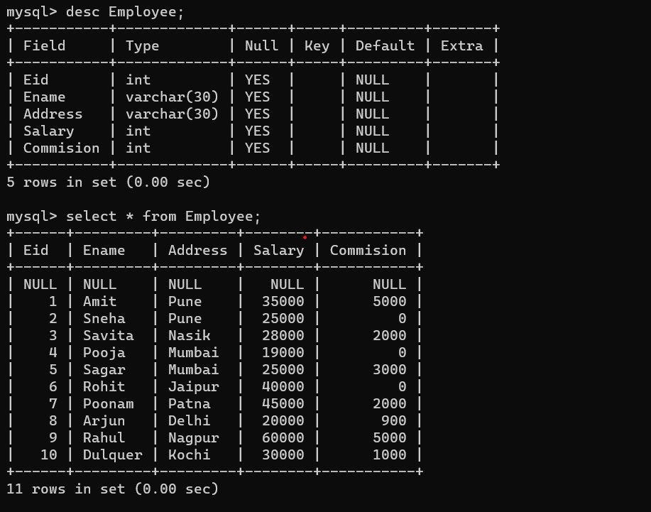

**mysql> insert into Project values(10,'Mumbai');**

Query OK, 1 row affected (0.00 sec)

**mysql> insert into Project values(20,'Pune');**

Query OK, 1 row affected (0.01 sec)

**mysql> insert into Project values(30,'Jalgaon');**

Query OK, 1 row affected (0.00 sec)

**mysql> insert into Project values(40,'Nagpur');**

Query OK, 1 row affected (0.00 sec)

**mysql> insert into Project values(50,'Delhi');**

Query OK, 1 row affected (0.00 sec)

**mysql> insert into Project values(60,'Kochi');**

Query OK, 1 row affected (0.00 sec)

**mysql> insert into Project values(70,'Pune');**

Query OK, 1 row affected (0.01 sec)

**mysql> insert into Project values(80,'Nasik');**

Query OK, 1 row affected (0.00 sec)

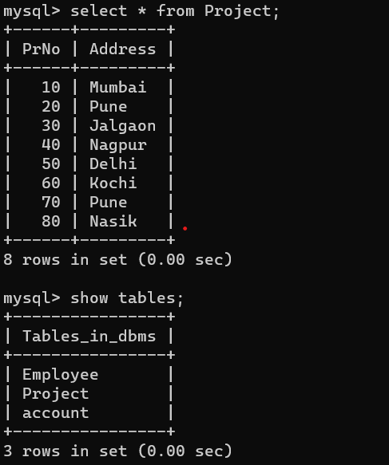

* **Execute the following queries in MySQL:**

1. Find different locations from where employees belong to?

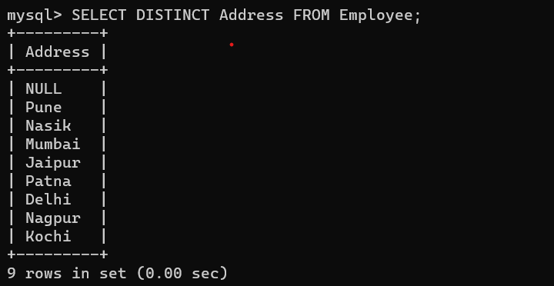

1. What are maximum ,minimum salary, average salary and sum of all salaries?

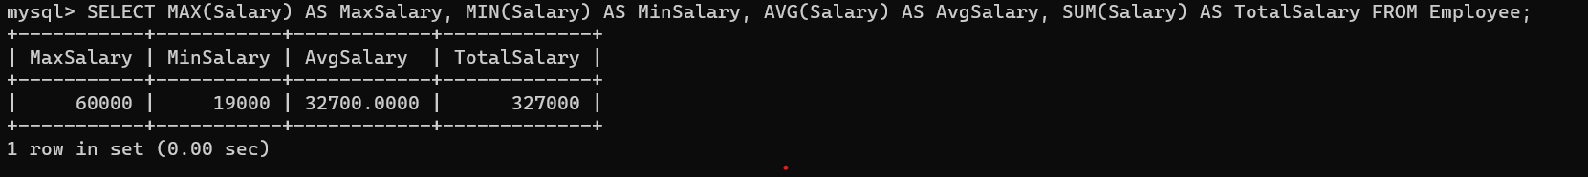

1. Display the content of employee table according to the ascending order of salary amount.

1. Find the name of employee who lived in Nasik or Pune city.

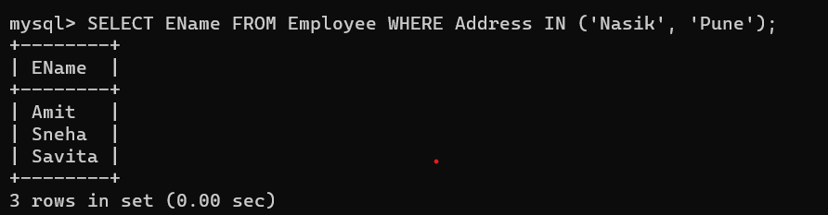

1. Find the name of employees who does not get commission.A black screen with white text

   Description automatically generated
2. Change the city of Amit to Nashik.

1. Find the information of employees whose name starts with ‘A’.

1. Find the count of staff from Mumbai.

1. Find the count of staff from each city

1. Find the address from where employees are belonging as well as where projects are going on.

(Use union operator)

1. Find city wise minimum salary.

1. Find city wise maximum salary having maximum salary greater than 26000

1. Delete the employee who is having salary greater than 30,000.

1. Delete the information of employees whose name starts with‘s’.

1. Display all the employee from Pune alphabetically.

